**LienCo Construction Website : LC1**

Contents

Description 2

Who: 2

WHAT: 3

WHY: 3

FUNCTIONAL REQUIREMENTS 4

NON-FUNCTIONAL REQUIREMENTS 6

# 

# Description

A website that provides its customers with various features for their construction needs.

A customer can

* Login to follow their on-going projects which are updated at the end of each work day. The customer can also make changes to the direction of the project.
* Request for a personnel to visit a site for assessment/quote.
* They can also get a rough estimate using the on-site calculator.
* Request an emergency repair via a one-click button.
* View information about the company
* Contact us page for queries .

# Who:

1. Client/Client representative

* The client or someone who represents the client which can identify and direct project needs.

1. Developer/Admin/Tech support

* Myself, Shaquille Neil will be responsible for all technical aspects of the website .

1. Stakeholder

* Will provide the guidance for front end features and also provide funding for the website.

1. Project Manager –

* Responsible for project updates at the end of day.
* Create project roadmap and direct planning
* Meet with client to ensure that project parameters are being met
* Monitor resource and funding allocation

# WHAT:

1. Emergency repair request based on location
2. Customer login platform for updating and managing projects
3. Quick and accurate quote generation based on information given
4. Node.js will be used to manage the backend
5. Oracle will be used to manage the website database
6. React.js will be used to manage the frontend

# WHY:

1. To increase efficiency with construction project management by providing a platform where a client can track, assess and make changes as needed.
2. To keep clients informed about the daily progress of their projects which helps to keep transparency and build trust.
3. To allow better resource and funding allocation, a client can actually see and keep track of where and what their resources are being spent.

# FUNCTIONAL REQUIREMENTS

* Client login/Project Management

1. The website must provide a secure login system for clients to access their accounts.
2. After logging in, clients must be able to view ongoing projects and view end of day updates.
3. Client should be able to request changes to the project direction through their account panel.
4. Client should be able to access their project’s history.
5. Client should have basic account modification controls, such as name changes and contact details updating.

* On-site Assessment Request

1. A form must be provided for an onsite assessment request. This form must contain the basic yet necessary information such as project type, site location and contact information.
2. A confirmation should be displayed to the client when their request has been received.
3. A notification should be sent to the client and the personnel chosen for the assessment. This notification should contain the time and date of the assessment.

* Estimate Calculation

1. Generate rough estimates based on specific input parameters
2. Accurate input validation
3. Client should be able to export / print estimates

* Emergency Request

1. Allows the user to request an emergency repair with one click.
2. Track the location of the emergency request to contact the closest person in the vicinity.

* Security

1. Client login and project information should be stored securely.
2. Ensure that clients can only access information that are pertinent to their account/projects.

# NON-FUNCTIONAL REQUIREMENTS

* Compatibility

1. The website should function across Chrome, Firefox, Safari and Edge.
2. The website should also be functional and responsive across laptops, phones and tablets.

* Scalability

1. The website should be able to scale easily with the increase in new clients

* Usability

1. A client should be able to navigate to any part of the website with just a simple click on the navigation bar.
2. Various “How to” instructions present on various pages to guide first time users
3. FAQ link available on each page that also answer any questions about the use of the website

Activity Diagrams

User activity diagram

Project manager activity diagram

SEQUENCE DIAGRAMS

User sequence diagram

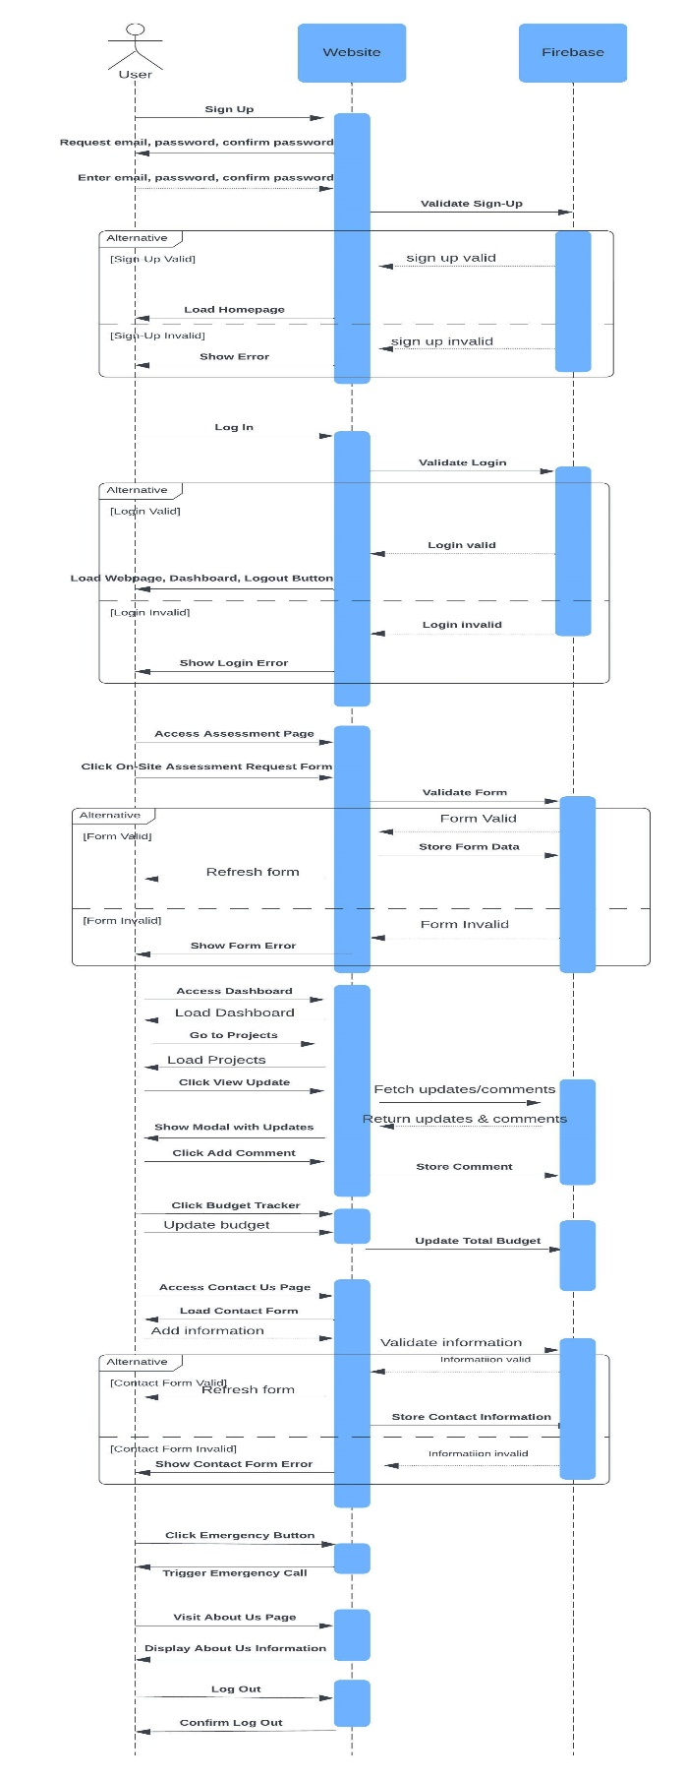

Project manager sequence diagram

